**OverTheWire Bandit - Level 3 to Level 4 Writeup**

**Introduction**: This writeup documents my experience solving Levels 3 to 4 of the OverTheWire Bandit challenge, a CTF-style game focused on learning about security concepts.

**Author**: Misha Jain

**Date**: October 19, 2023

**Tools Used:**

Terminal (SSH client)

**Challenge Description:**

Level 3 to Level 4 of Bandit involves connecting to a remote server via SSH and retrieving the flag located in the home directory of the server. These levels require basic shell commands and manipulation of files.

**Enumeration:**

For Level 3, we need to connect to the server using the credentials we obtained in Level 2. This will reveal a password for Level 4.

**Exploitation - Level 3:**

To connect to the server for Level 3 using SSH, we use the provided credentials:

ssh bandit3@bandit.labs.overthewire.org -p 2220

Use the password obtained from Level 2, which is aBZ0W5EmUfAf7kHTQeOwd8bauFJ2lAiG to gain access.

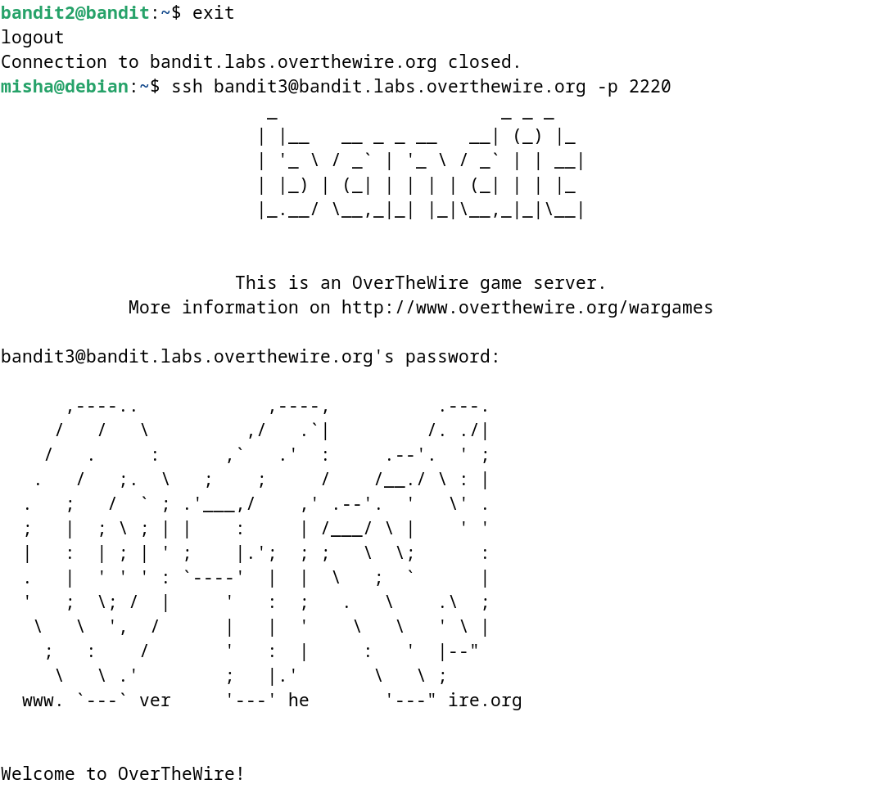

**Password Retrieval - Level 3:**

The password for Level 4 is stored in a hidden file in the inhere directory. We can use the cd command to change to this directory, the ls command to list the files in that directory, and then use the cat command to display the password:

cd inhere/

ls -alps

cat .hidden

These commands will display the Level 4 password.

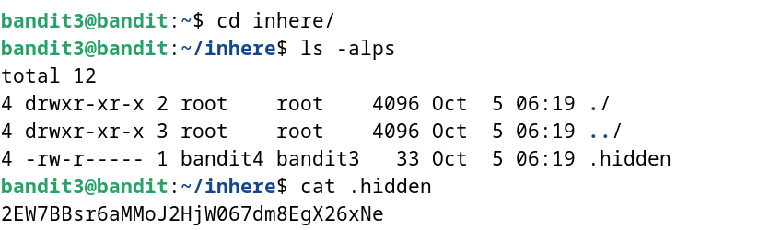

**Password – Level 4:**

The password for Level 4 is: 2EW7BBsr6aMMoJ2HjW067dm8EgX26xNe

**Exploitation – Level 4:**

Now that we have the Level 4 password, we can connect to the server for Level 4 using SSH:

ssh bandit4@bandit.labs.overthewire.org -p 2220

Use the Level 4 password to gain access.

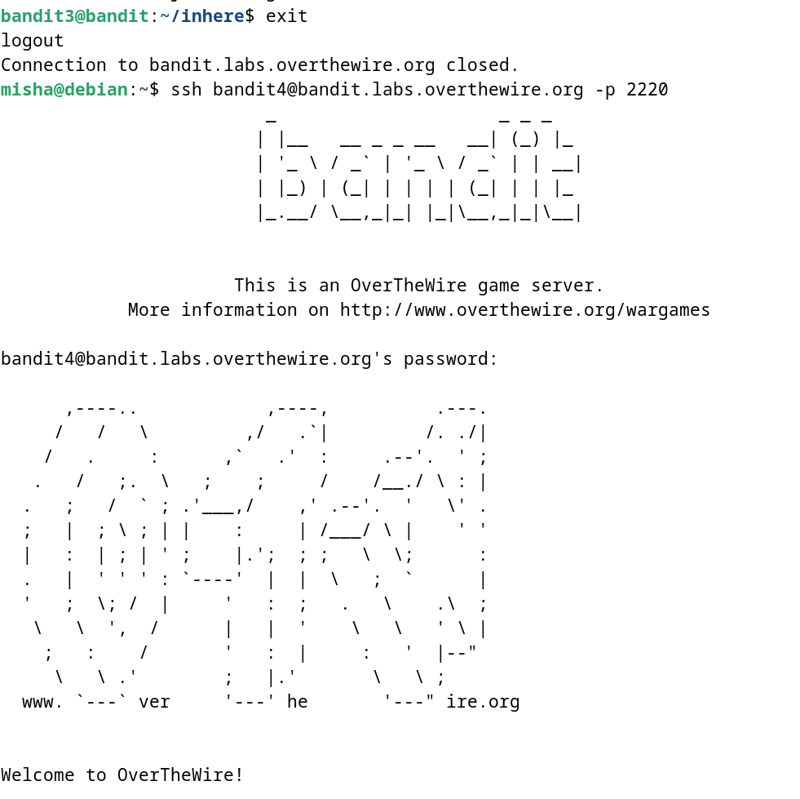

**Lessons Learned:** Level 3 to 4 introduced us to handling hidden files not located within the home directory.

**Conclusion:**

Levels 3 to 4 of the OverTheWire Bandit challenge continue to build on shell command knowledge while introducing new challenges. These levels are suitable for beginners to learn more about directory navigation and file manipulation.